**Exp 2 Design an LED Chaser light**

Circuit Diagram

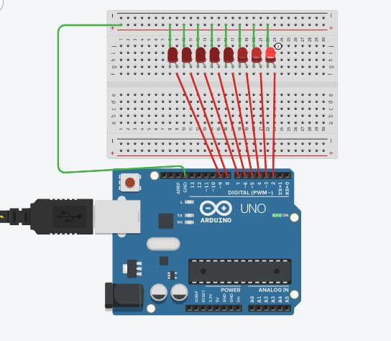

Theory

Concepts Used

1. Parallel circuit
2. Arduino Uno’s digital input/output pins
3. Code for the effects
4. Bread-board

Learnings and Observations

1. Improved problem solving and using genuino IDE.

Precautions

1. LEDs should be connected in right direction.
2. Check for any damages in the arduino cable.

Learning Outcomes

1. working of a bread-board
2. Improved understanding of the code used in Arduino IDE.